ASP.NET Core Web API – Hands-on 5
Aim: To implement JWT (JSON Web Token) Authentication in an ASP.NET Core Web API application and secure API endpoints using the Authorize attribute.
Theory:
- JWT (JSON Web Token): JWT is a secure, compact token used for user authentication and authorization between a client and server.
- Authentication & Authorization: Authentication verifies a user's identity, while authorization determines the resources or actions the authenticated user is allowed to access.
- Bearer Token: A Bearer token is sent in the HTTP Authorization header to access protected APIs.
- Authorize Attribute: The [Authorize] attribute restricts access to authenticated users only.
Procedure:
- Create an ASP.NET Core Web API project.
- Install the Microsoft.AspNetCore.Authentication.JwtBearer NuGet package.
- Configure JWT settings in appsettings.json and Program.cs.
- Create the User model and AuthController.
- Secure EmployeeController using the [Authorize] attribute.
- Run the application and generate a JWT token using the Login API.
- Use the generated JWT token to access the protected APIs using Swagger/Postman.

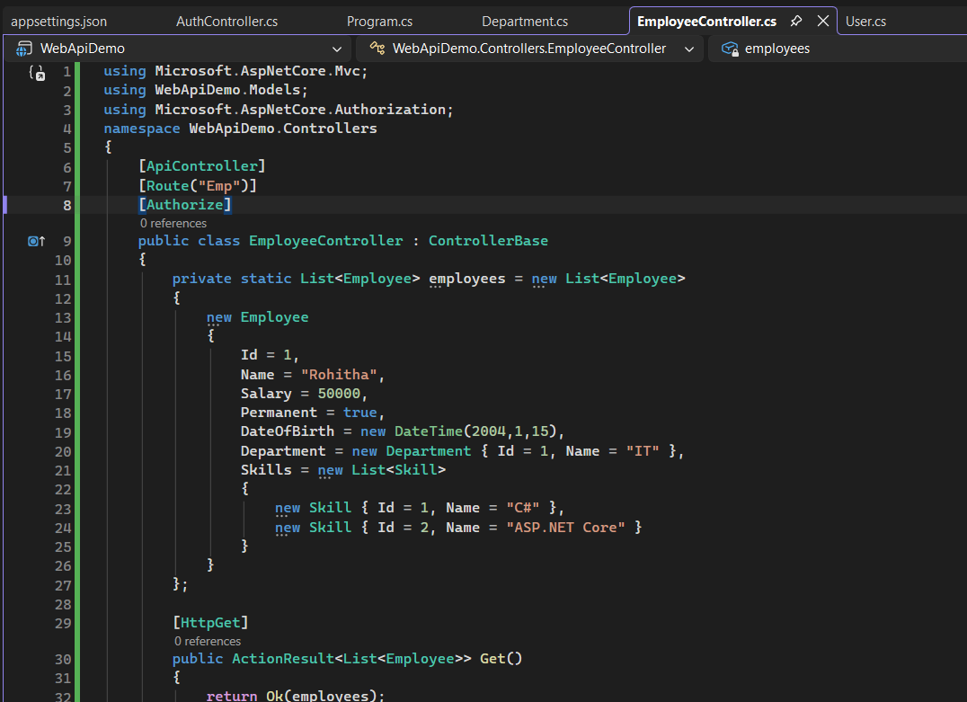
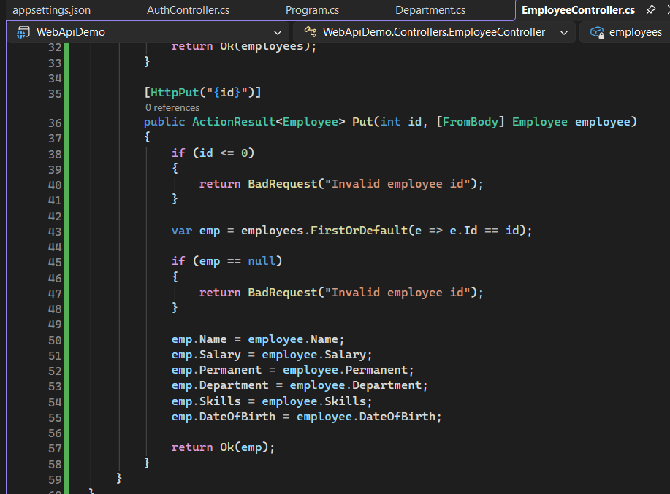
EmployeeController.cs:

Appsettings.json:
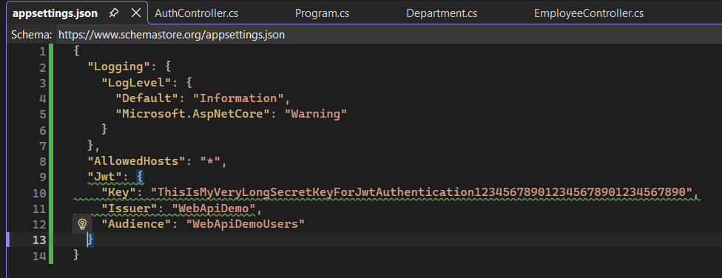
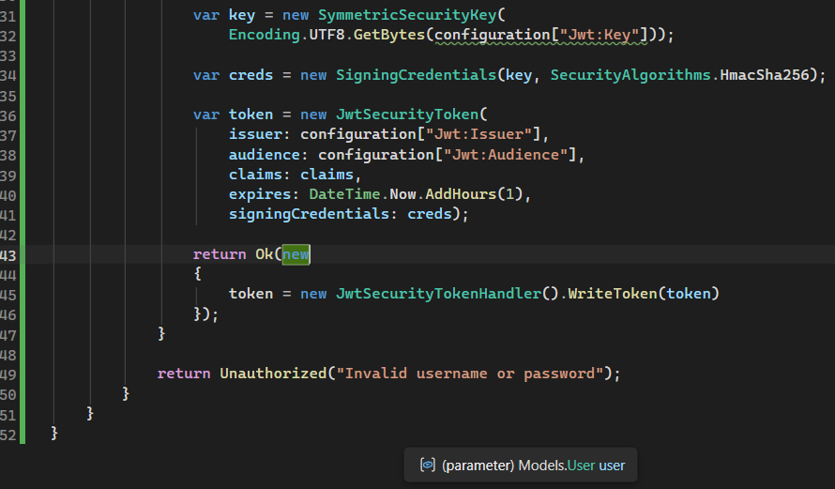
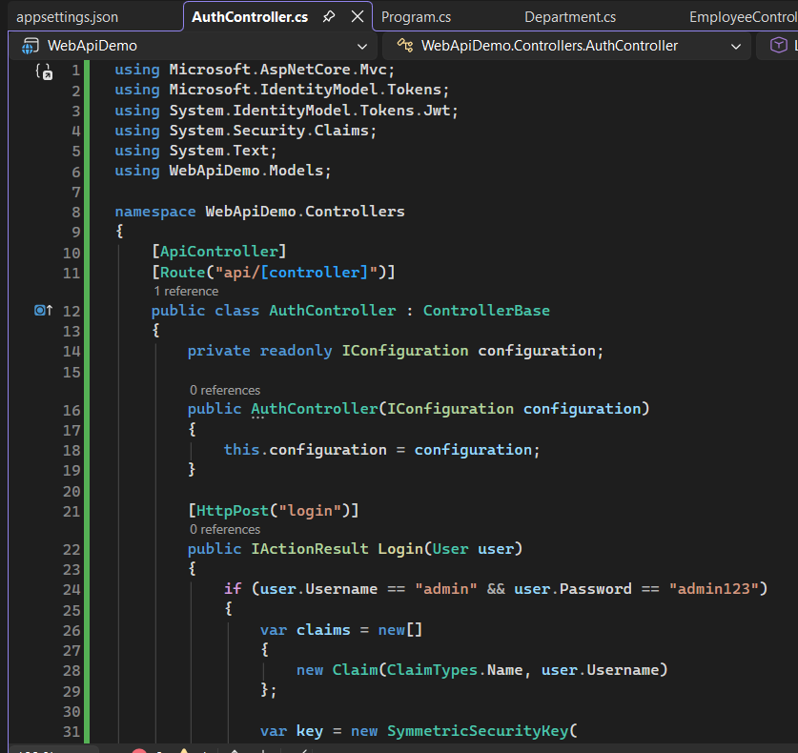
AuthController.cs:

Program.cs:
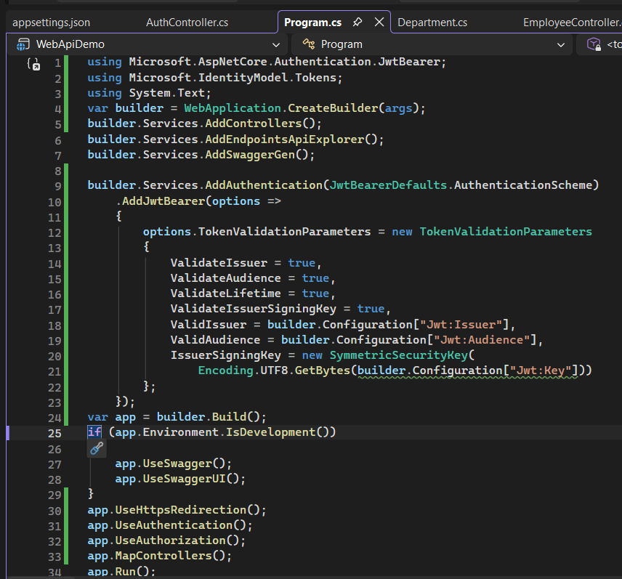

User.cs:
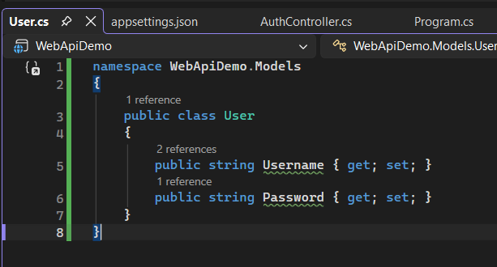
Output:
POST /api/Auth/login
